**MindBodyU – Final Project Writeup**

***Team: Nidhi Padmanabhan, Ghea Chaw, Yu Qing Peng***

**Project Proposal Summary**

It is very common for college students to overlook their overall well being or to compromise on certain aspects of a healthy lifestyle amidst their busy schedule of extracurriculars and academics. Our application, MindBodyU, is designed to be a comprehensive health and wellness platform specifically geared towards college students. It aims to provide solutions for four major wellness-related needs—nutrition, fitness, mental health, and academics. The primary audience for this application is college students who are looking for a condensed set of tips and information regarding how to take care of themselves physically, mentally, and academically. It also enables these students to instill an effective method to help them maintain a healthy lifestyle with the resources available to them. While there are many applications which address specific aspects of wellness, such as mindfulness apps, online calendars, nutrition apps, and fitness trackers, our application stands out due to its well-rounded nature and its specification towards college students. As college students ourselves, we are in a unique position to truly make an impact with this application, as we understand the wellness needs of college students. With the understanding that academics is a major part of a college student’s lifestyle, unlike other wellness apps, we place emphasis on this aspect of wellness as well.

**User Personas**

While creating this webpage we thought of two user personas who might decide to utilize it. These were two students who might be seen roaming along a college campus. The first was Samantha, she was a current freshman who is a CS major with anxiety. This first year had been very stressful for her and she felt that she was falling behind in her classes. She can use MindBodyU to discover some mindfulness tips and techniques to help with her stress. She can also utilize our assignment tracker to keep track of her upcoming quizzes and tests. The second persona was Jeremy. He was a business major who is currently sporting an unhealthy lifestyle. He never exercises and practically only consumes pizza. Jeremy could use our workout generator to generate workouts that he might like, along with our workout tracker to track his progress. Additionally, he can use our meal plan generator to find a variety of healthy meals to try to find more meals he enjoys.

**Project Plan**

At the start of our project we picked two main focus areas–HTML, CSS, and Graphics & Javascript Interactivity–and our project plan revolved around emphasizing the integration of these two areas. We set up a chart with a timeline and all of our tasks to complete the project and visualize our progress. Overtime, we realized that we would have to adjust this timeline so that we could meet the deadline in a shorter time span, as some tasks which were newer to us, such as API usage, took longer than expected. Additionally, since our project involved a lot of research-related tasks, we created a separate document to keep track of our progress on this end as well. (Project Plan Chart: <https://docs.google.com/spreadsheets/d/1wAgbrM1jkYdKXThSpLApYq8GcH7nnWO7V1XhpAgtn-I/edit?usp=sharing> , Research Planning Document: <https://docs.google.com/document/d/1S0ADcq4hEP4ZoGhhdn9dK4zi3-492y08oE8GUjPUrqc/edit?usp=sharing> )

**Information Architecture**

Our Information Architecture for this project gradually changed over time. Initially, we had just one CSS & JavaScript file for the entire web application. However, as we began working on the project, we came to realize that the files were getting too convoluted with all of the styling, jQuery, and JS for each page in one place. For this reason, we added an individual JS and CSS page for each of the pages on our webpage and placed the files related to each specific page inside of a singular folder for the page. We currently have a folder for each of our pages (AboutMe, Academic, Calendar, Fitness, Mental, Nutrition, Login, and SignUp) with the corresponding CSS and JS files inside of these folders. Our index.html file for the homepage, along with the CSS and JS files for the homepage are the only files directly in our root directory. Additionally, we have a Resources folder with all of the images we planned on using or used in our implementation, a Mockups folder with all of the images from our figma mockup for this project, and a Miscellaneous folder with all of our relevant research and write ups. This IA can be easily navigated due to its organized and consolidated nature.

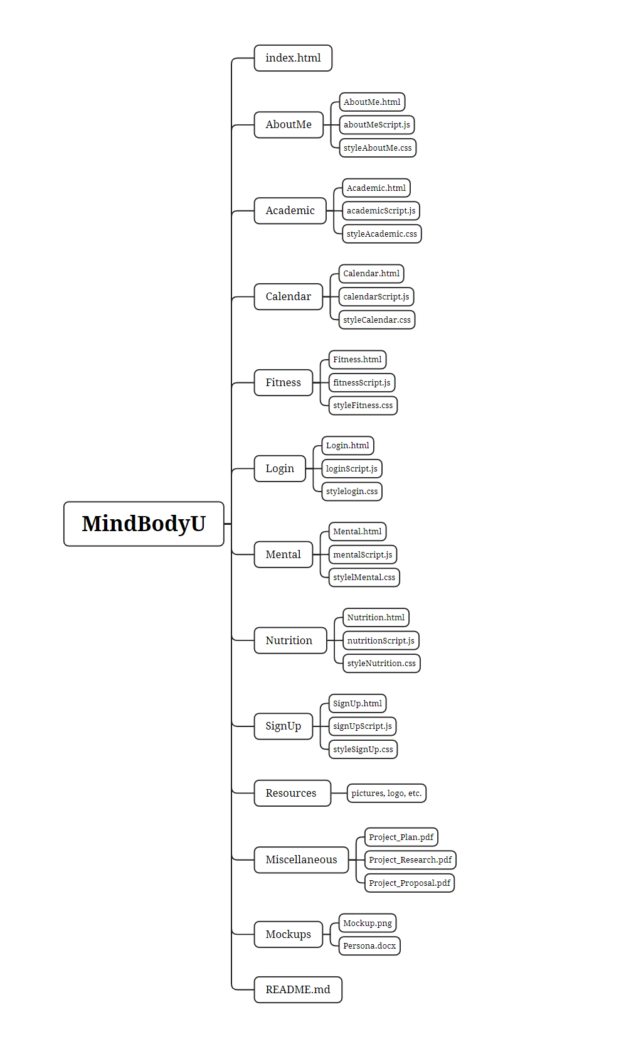

**Description of Project Implementation & Future Plans**

Our project has five main pages– an academics page, a fitness page, a mental health page, a nutrition page, and a calendar page.

Our academics page provides a comprehensive academic guide with study tips, time management tips & techniques, stress management tips, time management techniques, and links to helpful external resources, including planners/calendars which are beneficial for college students. This page also provides an assignment tracker which allows users to input classes they are currently taking, correlate them to a color, and add assignments for all classes into one visually appealing and easy-to-use table. The table allows you to organize assignments by type (homework,lab, project, presentation, quiz, midterm, final, etc. ), date, and class and sorts all assignments automatically by date. In the future, we would like to add more functionality to our assignments tracker by providing users with notifications on the day prior to and the day when an assignment is due.

The Fitness page provides a comprehensive fitness guide with the various health benefits of fitness and the different types of exercise, along with examples of each type. This page also provides a fitness planner which allows users to keep track of exercises to do, exercises in progress, and exercises finished with a user-friendly design so that users could easily keep track of their workouts. Another feature on this page is a workout generator which was implemented using the API Ninjas Exercise API. Using JavaScript, we took user input through the workout generator (exercise type, muscle type, and difficulty level) and used form validation to ensure all input was valid. Then, using Ajax, we concatenated the user input to generate the api call and fetch the response data in a JSON format. We parsed through this data in order to display 10 exercises to the user with equipment and instructions listed. In the future, if possible, we would like to be able to filter out exercises according to equipment available to the user, making our workout generator more functional for college students. We would also like to add a progress bar to the workout plan tracker so that users could be more motivated to complete their workouts.

The Mental Health page provides a comprehensive mental health guide with tips on how to actively take care of your mental health on a daily basis and ways to practice mindfulness. We have information on the basics of mental health and mindfulness, as well as the importance of both of these factors with regards to a college student’s lifestyle. This page also provides resources to meditation playlists, descriptions for useful apps, and links to hotlines and counseling resources.

The Nutrition page provides a comprehensive nutrition guide with information about each of the food groups, the daily recommendation for each food group, and examples of foods you can eat from each group. This page also provides a meal plan generator which was implemented using the Spoonful Meal Planner API. The implementation process for this was similar to that of the workout generator we integrated into our fitness page. The end result for this meal plan generator is a display of three meals for a day (breakfast, lunch, dinner) which fits the users nutritional goals. In the future, we would like to implement a filter which allows users to input the equipment they would like to include/exclude (depending on available resources). This feature would make this meal planner more functional for college students, given their constraints in a college dorm.

Our Calendar page currently has only the UI implemented which is a weekly calendar with a section to add tasks for each day. In the future, we would like to expand on the functionality of this page in many ways. The first would be to fully implement the existing calendar using Javascript to enable users to input tasks for each day of the week and implement a habit tracker for each day which would allow users to keep track of healthy habits and motivate them to continue maintaining these habits. Additionally, we would add a progress bar for tasks and habits so users can visualize how much they have accomplished each week. Lastly, we would provide notifications for users to let them know when tasks are coming up and how long they have held their habit streaks. All of these features combined would optimize user productivity and motivate them to continue maintaining a healthy lifestyle.

Additionally, we have a Login and Sign Up page which we began the implementation for on our site. Currently, both of these pages only have the UI and form validation using JavaScript completed. However, moving forward, we would like to implement these pages using PHP & MySQL so that users could save all of their workout plans, meal plans, assignments, and calendar tasks.

**Challenges & How We Approached Them**

In building our health website, we faced several challenges. First, choosing a name was tough, so we turned to GPT-4 for suggestions. While the names it provided weren’t perfect, they inspired our final choice. The next challenge we faced was in formatting our CSS files. We discovered that as our website grew, our CSS files became longer and more complex, further complicated by overriding styles that made formatting extremely difficult. We improved this by using clear, descriptive names throughout all files and adding several comments in our code for better management. Implementing and debugging APIs was another challenge due to our limited experience. However, with help from the online API documentation and insights from our previous JSON & Ajax labs, we managed to integrate the APIs successfully. Along the same lines with API implementation, we used debugging techniques like error alarms and print statements to address issues, such as invalid data inputs.

**Conclusions**

This project enabled us to develop a lot of our technical and soft skills. With regards to technical skills, we became proficient in JavaScript, jQuery, API implementation, JSON & Ajax usage, and creating a visually pleasing design with HTML & CSS. In terms of our soft skills, this project really helped us hone in on our project management and collaboration abilities as a team. We had to learn to set deadlines and adjust our timeline as needed, as well as how to progress through the project development process from the initial steps of brainstorming a solution to mockup design, implementation, and deployment. After going through the planning stage and running through various stages of our implementation, we finally ended up with a prototype for MindBodyU which highlights our primary features and encompasses our initial goal to create a centralized wellness platform for college students.